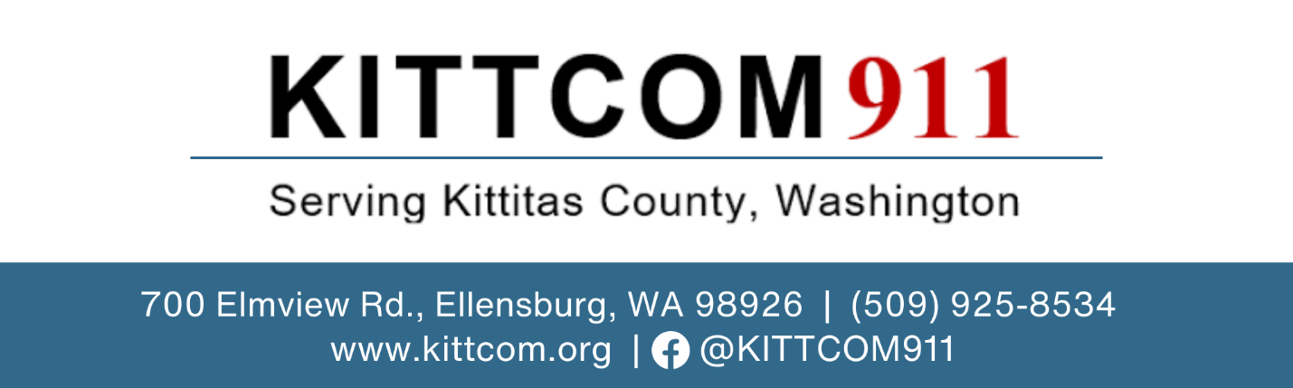

FOR IMMEDIATE RELEASE

Date: April 1, 2024
Contact: Rich Elliott | 509-925-8530 | fundingquestions@kittcom.org

Community invited to learn more about sales tax to improve public safety
Proposition will appear on the April 23, 2024, special election ballot

ELLENSBURG, WASH. – KITTCOM invites the community to learn more about the sales tax measure that will be on the April 23, 2024, special election ballot. The purpose of the ballot measure is to improve and secure a sustainable funding source for the countywide 911 communications system.

Learn more at upcoming Q&A sessions:

- Saturday, April 6, KITTCOM, 700 Elmview Road – 11 a.m. to 12 p.m.
- Thursday, April 11, Kittitas Valley Fire and Rescue Station 29, 400 E. Mountainview Ave. – 6 p.m. to 7 p.m.

KITTCOM Interim Director Rich Elliott will deliver a short presentation and answer any questions.

KITTCOM answers and coordinates 911 services for all 17 public safety agencies in Kittitas County, including fire, emergency medical service (EMS), police, and search-and-rescue. Its emergency radio system and communications infrastructure are outdated and unreliable in many parts of the county, which poses significant challenges for first responders and search teams to coordinate and communicate during emergencies.

There are many locations in the county where radio signals are not reliable or nonexistent including in the Cle Elum River Valley, Suncadia, Yakima River recreational areas, ski areas, rural schools and homes, and in the many new residential and recreational developments in the county. These “radio holes” or “dead zones” impact response times, patient care, wildland fire suppression, and rescue operations.

Kittitas County is asking voters for a two-tenths of 1 percent sales tax increase (two cents per every $10 purchase). If approved by voters, the sales tax would fund radio equipment, communications towers, technology improvements, security and other critical infrastructure, and maintenance costs.

Why a sales tax?
Visitors and people traveling through the county should also contribute to the 911 system. KITTCOM serves nearly 50,000 residents plus thousands more who come to recreate or attend festivals. Seasonal and weekend visitors can triple and, at times, quadruple the population in some areas. Approximately 33,000 vehicles pass through Kittitas County every day on Interstate 90 for food, fuel, and lodging. More people living in and visiting the county are straining the outdated and aging 911 system.

The small sales tax is a sustainable funding source and would apply to visitors and people coming to recreate or passing through. In 2022, visitor spending in Kittitas County totaled $311 million. This spending included recreational supplies, food and beverage, gas, car rentals and bus fares, and retail sales. Hotel stays through June 2023 totaled 258,125 rooms rented – 80 percent of hotel guests are visitors.

KITTCOM currently funds its 911 system through cell phone and user agency fees paid for through local property taxes. In the last three years, user agency fees increased by 50 percent. When user agency fees increase, it reduces the amount of revenue they have for their daily operations to pay for the emergency personnel, equipment, ambulances, and fire engines all residents require. This funding source is not sustainable for the 911 system or user agencies.

Learn more at www.kittcom.org. KITTCOM Interim Director Rich Elliott also welcomes any questions at 509-925-8530 or fundingquestions@kittcom.org.

###

KITTCOM answers and coordinates 911 service for all 17 public safety agencies throughout Kittitas County, including fire, emergency medical service, law enforcement and disaster response agencies. The agency serves both Kittitas County residents (population nearly 50,000), non-residents and visitors who come to the county for recreational opportunities. The agency responds to more than 48,000 calls per year.

